**ATOMIC FORCE MICROSCOPE**

**BITS F415: Introduction to MEMS**

**Project Work**

**Project Work carried out by**

**TEAM P**

Rahul Jindal (2018A4PS0402G)

Tushar Gupta (2019A4PS0046G)

Archit Sharma (2019A4PS0303G)



**BIRLA INSTITUTE OF TECHNOLOGY & SCIENCE**

**PILANI (RAJASTHAN)**

April 2022

**ATOMIC FORCE MICROSCOPE**

**BITS F415: Introduction to MEMS**

**Project Work**

**Project Work carried out by**

**TEAM P**

Rahul Jindal (2018A4PS0402G)

Tushar Gupta (2019A4PS0046G)

Archit Sharma (2019A4PS0303G)

Submitted in partial fulfillment of BITS F415 (Introduction to MEMS) course

Under supervision of

Dr. Devendra Patil



**BIRLA INSTITUTE OF TECHNOLOGY & SCIENCE**

**PILANI (RAJASTHAN)**

April 2022

**DECLARATION BY THE STUDENT**

I, **Rahul Jindal**  hereby declare that the project report entitled "**Atomic Force Microscope**" submitted by me to BITS Pilani, KK Birla Goa Campus, in partial fulfillment of **BITS F415 (Introduction to MEMS)** **Sem. II AY 2021-22** course is a bonafide report based on the work carried out by me and my **Team P** during the course of my study under the supervision of Dr. Devendra Gokul Patil.

I contributed to literature review, simulation and result analysis.

I assure that the statements made and the conclusions drawn are an outcome of the project work. I further declare that to the best of my knowledge, the report does not contain any part of any work which has been submitted by someone else in any other publication.

Place: BITS Pilani KK Birla Goa Campus

Date: 02/05/2022

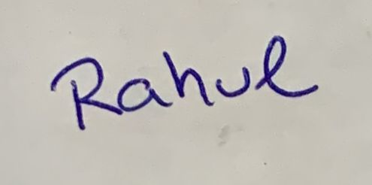

Signature of candidate :

Student Name : Rahul Jindal

Student ID : 2018A4PS0402G

**DECLARATION BY THE STUDENT**

I, **Tushar Gupta** hereby declare that the project report entitled "**Atomic Force Microscope**" submitted by me to BITS Pilani, KK Birla Goa Campus, in partial fulfillment of **BITS F415 (Introduction to MEMS)** **Sem. II AY 2020-21** course is a bonafide report based on the work carried out by me and my **Team P** during the course of my study under the supervision of Dr. Devendra Gokul Patil.

I contributed to the literature review, result analysis and Micro-manufacturing AFM tip

I assure that the statements made and the conclusions drawn are an outcome of the project work. I further declare that to the best of my knowledge, the report does not contain any part of any work which has been submitted by someone else in any other publication.

Place: BITS Pilani KK Birla Goa Campus

Date: 02/05/2022

Signature of candidate :

Student Name : Tushar Gupta

Student ID : 2019A4PS0046G

**DECLARATION BY THE STUDENT**

I, **Archit Sharma** hereby declare that the project report entitled "**Atomic Force Microscope**" submitted by me to BITS Pilani, KK Birla Goa Campus, in partial fulfillment of **BITS F415 (Introduction to MEMS)** **Sem. II AY 2020-21** course is a bonafide report based on the work carried out by me and my **Team X** during the course of my study under the supervision of Dr. Devendra Gokul Patil.

I contributed to the literature review, created the CAD models for the AFM cantilever, and carried out the Structural/Modal simulations on Ansys.

I assure that the statements made and the conclusions drawn are an outcome of the project work. I further declare that to the best of my knowledge, the report does not contain any part of any work which has been submitted by someone else in any other publication.

Place: BITS Pilani KK Birla Goa Campus

Date: 02/05/2022

Signature of candidate :

Student Name : Archit Sharma

Student ID : 2019A4PS0303G

**ABSTRACT**

Atomic Force Microscopy (AFM) is a branch of scanning probe microscopy that utilizes a fine tip/probe to produce high-resolution profiles of a surface. The method measures the forces between the surface and the tip while it is driven along the surface. AFM circumvents the diffraction limit that impedes optical microscopes, yielding resolutions in order of nanometers (depending on tip size). One of its first major applications was in NASA's Rosetta mission, where MIDAS (Micro-Imaging Dust Analysis System) was used to analyze cometary dust particles; And still finds uses in interplanetary probes to image fine dust particles.

The project aims to test AFM cantilever made of different materials and perform simulations using ANSYS 2022 Software. Isotropic Si, Anisotropic Si, and Crysalized Al were the different materials used in this project.

Isotropic Si had a strain of 0.13542E-3, Anisotropic Si had a strain of 0.1659E-3, and Crystalline Al had a strain of 0.1422E-3.

The project concludes that Si would be the best material for space application.

**Table of Contents**

1. **Introduction ______________________________ 9**
2. **Background _______________________________ 9**
3. **Literature Review _______________________________ 9**
4. **Project Discussion ______________________________ 10-11**
5. **Results ______________________________ 12-17**
6. **Conclusion _______________________________ 17**
7. **Direction for future work _______________________________ 17**
8. **Bibliography and references _______________________________17**
9. **Simulation files and data ________________________________18**

|  |  |  |  |
| --- | --- | --- | --- |
| **List of Figures** | | | |
| **Sr. No** | **Figure No.** | **Figure Title.** | **Page No.** |
| 1 | 1 | CAD MODEL of the AFM | 10 |
| 2 | 2 | Magnified view of tip | 10 |
| 3 | 3 | Geometry Details | 10 |
| 4 | 4 | Isotropic view of mesh | 11 |
| 5 | 5 | Side View of Mesh | 11 |
| 6 | 6 | Equivalent Elastic Strain simulation for Isotropic Si | 12 |
| 7 | 7 | Equivalent Elastic Stress Simulation for Isotropic Si | 12 |
| 8 | 8 | Total Deformation Simulation for Isotropic Si | 13 |
| 9 | 9 | Modal Vibration Analysis for Isotropic Si | 13 |
| 10 | 10 | Equivalent Elastic Strain simulation for Anisotropic Si | 14 |
| 11 | 11 | Modal Vibration Analysis for Anisotropic Si | 14 |
| 12 | 12 | Equivalent Elastic Strain simulation for Crystalline Al | 15 |
| 13 | 13 | Modal Vibration Analysis for Crystalline Al | 15 |
| 14 | 14 | Scanning electron microscopic image of a deposited micro tip | 16 |
| 15 | 15 | magnified view at the apex of scanning electron microscope | 17 |

1. **Introduction**
   1. **Motivation**

Atomic Force Microscope can be used to better understand the surface of different planets. We can directly observe the surface of different planets in space and produce high-resolution images in situ.

* 1. **Aim, Objectives and Scope of the project**

1. **Aim –**

Develop Atomic Force Microscope for application in Space

1. **Objective -**

Test AFM cantilevers made of different materials for application in space

Perform modal vibration analysis.

1. **Scope –**

AFM cantilever CAD model was designed using and Solidworks and simulated with Ansys. 3 different materials - Isotropic Si, Anisotropic Si, and Crystalline Al were studied in the project.

1. **Background**

Atomic Force Microscope can be used to study surface properties like adhesion, friction, electric, magnetic force, topographical imaging of dust particles in space. AFM uses a fine tip to produce high resolution profiles of a surface. The resolution usually ranges in nanometers.

AFM cantilevers made of different materials were designed and simulated to better understand which material would be best for application in space.

1. **Literature review**

**F J Espinoza-Beltrán et al 2009 New J. Phys. 11 083034** simulates vibrational resonance frequencies of AFM made of silicon by FEM method. The paper uses measured resonance frequencies of an individual cantilever to fit the geometrical dimensions of the cantilever beam model. The paper measures the resonant frequencies of the same cantilever in contact with a sample and determines the out-of-plane and in-plane tip-sample contact stiffness values by a fitting procedure.

**MIDAS: lessons learnt from the first space borne AFM**

AFM was first used in space in NASA’s Rosetta Mission and was used to study cometary dust particles. The key recommendations are to use a variety of cantilevers with different spring constants and a variety of tip geometries.

1. **Project Discussion**

**Geometry**

The CAD model was designed using SolidWorks in accordance with the paper.

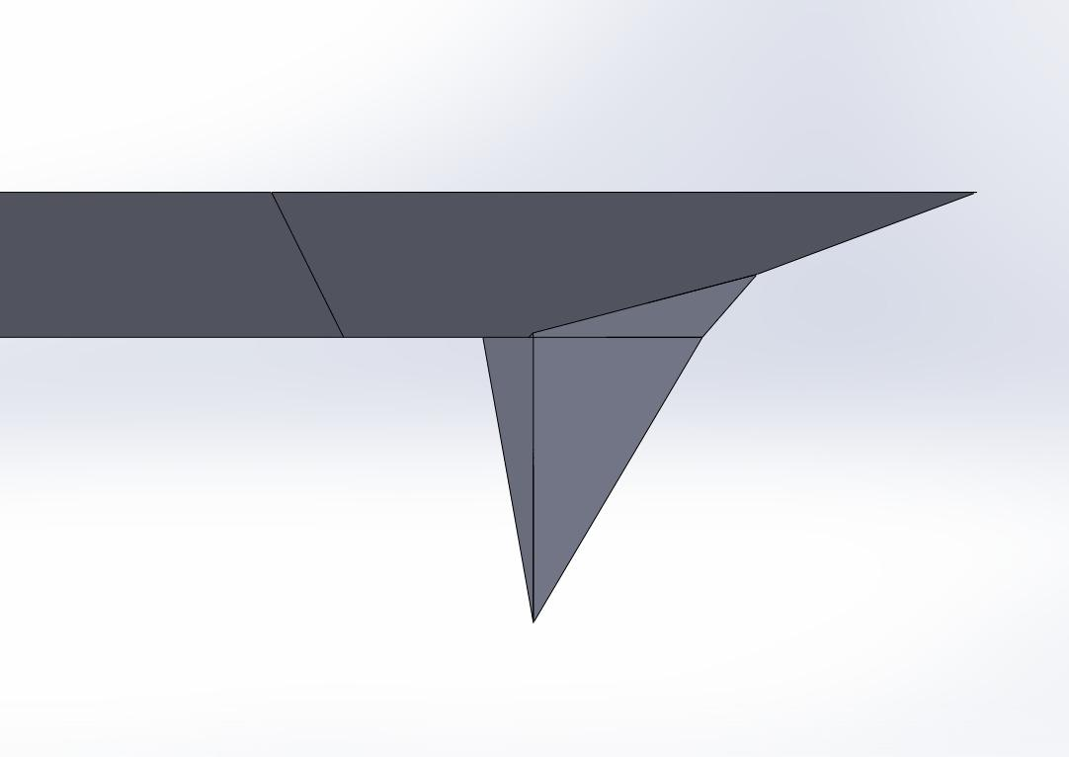

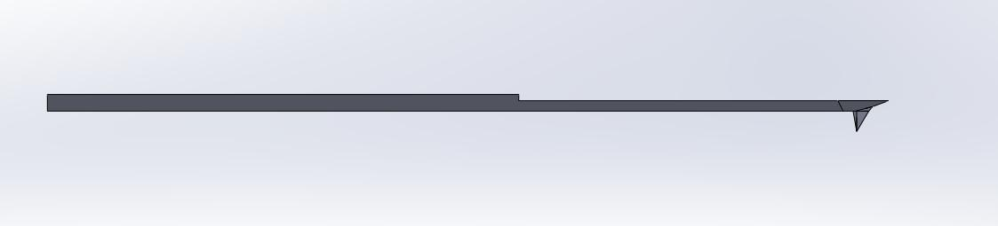

**Fig 1** CAD model of the AFM

**Fig 2** Magnified view at the tip

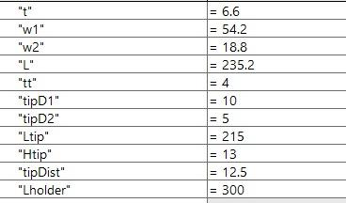

**Fig 3 Geometry details**

**Meshing**

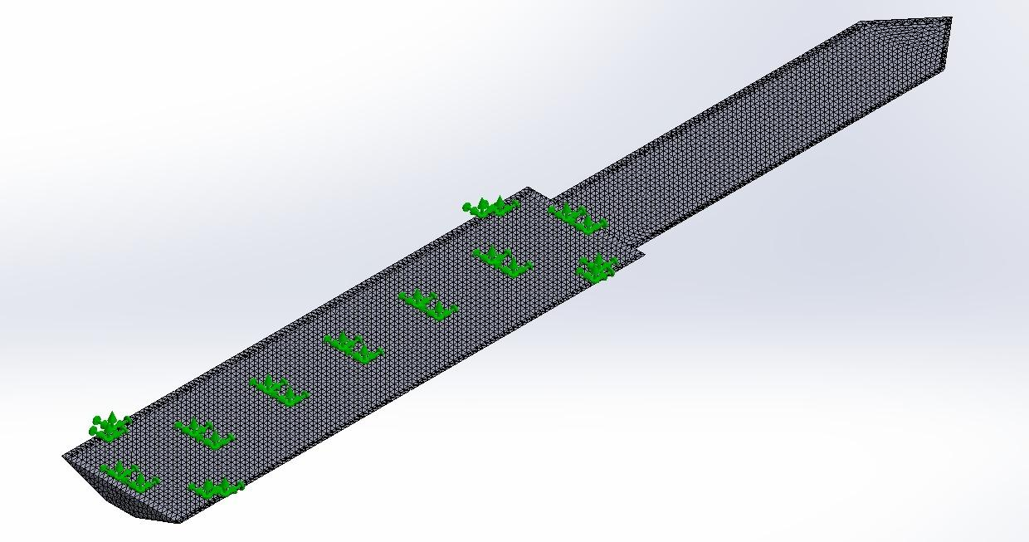

**Fig 4 Isotropic View of meshed model**

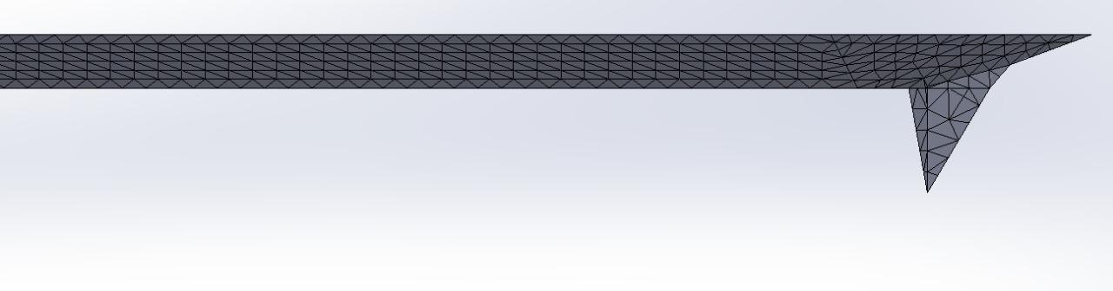

**Fig 5 Side view of the model**

A fine mesh was produced using Solidworks.

1. **Discussion of the Results**

The mesh was imported into Ansys workbench to carry out Structural (FEM) analysis and Modal analysis.

Modal analysis was used to cross-verify results with the paper.

Structural analysis was used measure the viability of the cantilever under deflection. Equivalent strain, stress and total deformation was simulated under 6 nm tip deflection. Single crystal silicon was compared to anisotropic silicon and crystalline aluminum.

**Isotropic Si**

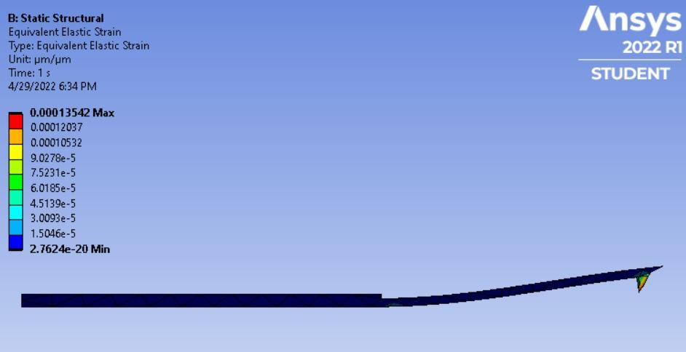

**Fig 6 Equivalent Elastic Strain simulation for isotropic Si**

**Equivalent Elastic Strain :** 0.13542E-3 (max)

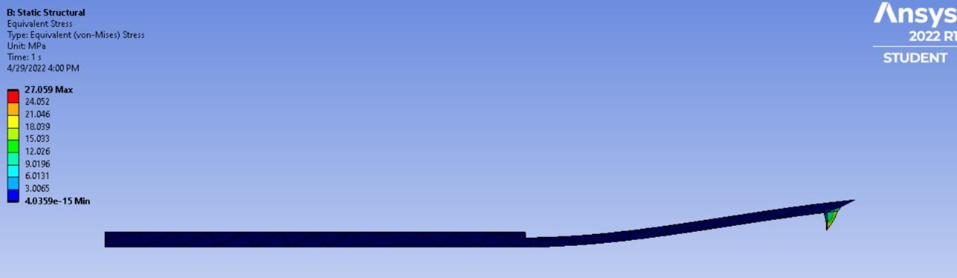

**Fig 7** **Equivalent Stress Simulation for Isotropic Si**

**Equivalent Stress : 27.059(Max)**

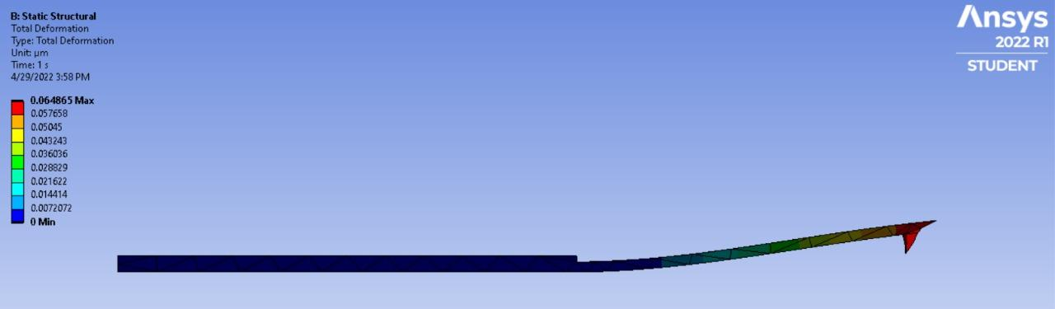

**Fig 8 Total Deformation Simulation for Isotropic Si**

**Total Deformation : 0.064865(Max)**

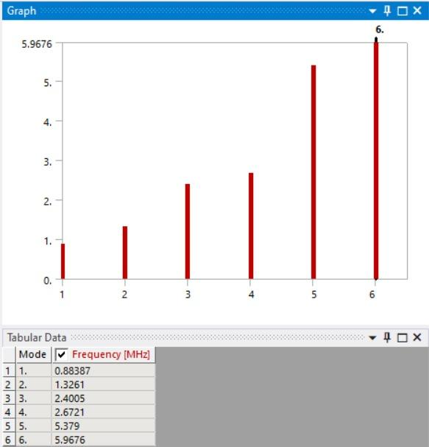

**Fig 9 Modal Vibration for Isotropic Si**

**Anisotropic Si**

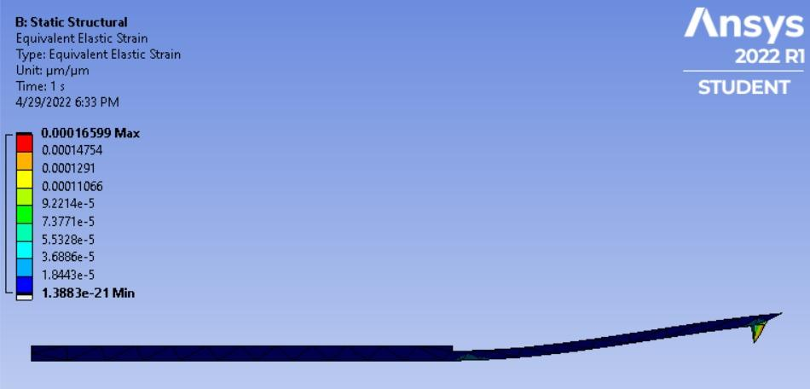

**Fig 10 Equivalent Strain Simulation for Anisotropic Si**

**Equivalent Strain: 0.1659E-3**

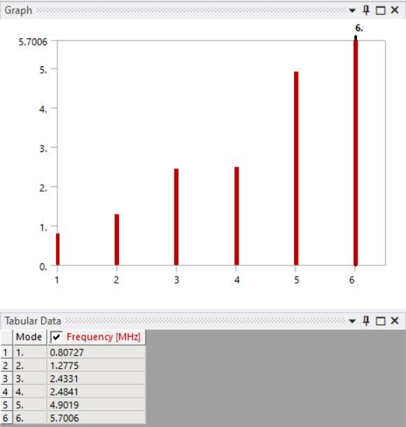

**Fig 11 Modal Vibrations for Anisotropic Si**

**Crystalline Al**

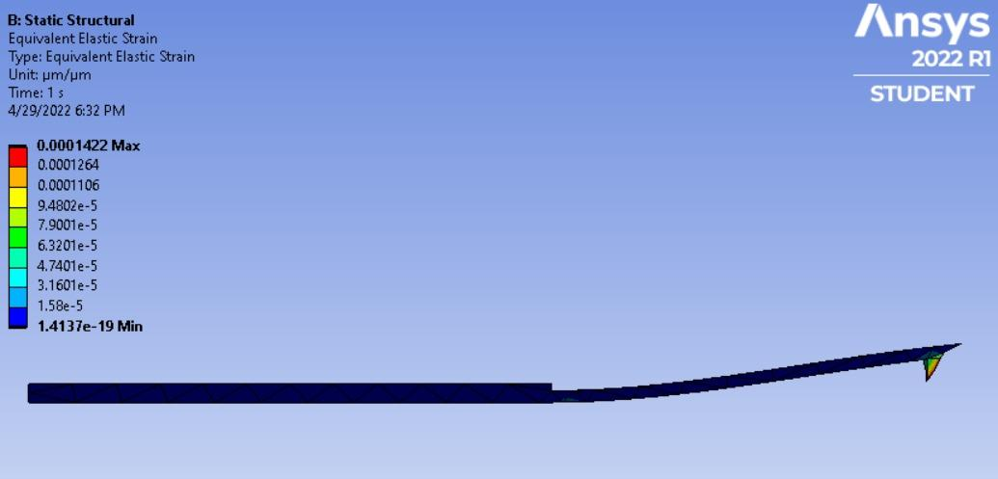

**Fig 12 Equivalent Strain Simulation for Crystalline Al**

**Equivalent Strain 0.1422E-3(max)**

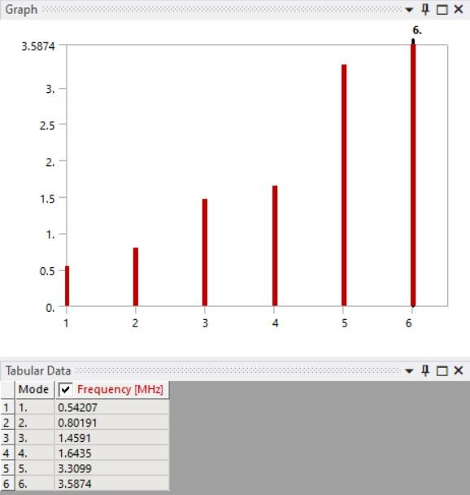

**Fig 13 Modal Vibrations for Crystalline Al**

The simulations show that Aluminium and Isotropic Silicon have comparable strain values at an equal deflection of 60 nm but Aluminium is much tougher than Silicon. Toughness of Aluminium ranges from 14-28 Mpa/m^½ whereas toughness of isotropic silicon is 0.9 Mpa/m^½ . This gives Aluminium a better use for Space applications.

Now we discuss how to micro-manufacture Aluminium Atomic Force microscopes. The tip is made by a shadow mask process where Nickel or Chromium is used as the shadow mask. Aluminium is deposited through vacuum evaporation process. The Cantilever is made using a sacrificial layer and removing it after the desired geometry is acquired.

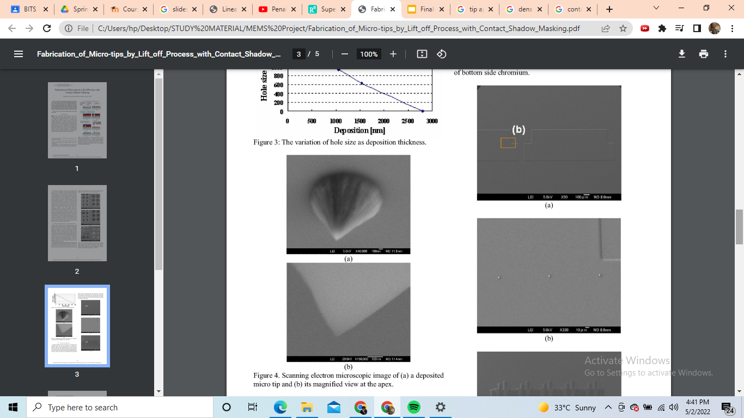

**Fig 14 Scanning electron microscopic image of a deposited micro tip**



**Fig 15 magnified view at the apex of scanning electron microscope**

The tip radius of curvature is approximately 40 nm. The range for a AFm tip is 5-50 nm. Despite being on the higher end of the tolerance range, it is still acceptable.

1. **Conclusion**

In this Project, AFM cantilever made from different materials has been designed and simulated. Isotropic Si, Anisotropic Si, and Crystalline Al were the different materials tested in this project. An equal deflection of 60 nm was used to calculate strain. For extreme conditions in space, Crystalline Al is preferred for making a Space application based AFM.

1. **Directions for Future Work**

A more precise way to manufacture Aluminium Tips needs to be found to increase the precision of these Aluminium Atomic Force Microscopes. A more economical way of manufacturing would also help as vacuum evaporating Aluminum is an expensive method

1. **Bibliography and References**

[1] F J Espinoza Beltran et al 2009 New J. Phys. 11 083034, “ Simulation of vibrational resonances of stiff AFM cantilevers by Finite Element Method”

[2] M.S. Bentley, H. Arends, B. Butler, “ MIDAS: Lessons learned from the first spaceborne Atomic Force Microscope”

[3] Fabrication of Micro-tips by Lift off Process with Contact Shadow Masking Honam Kwon, Akio Higo, and Hiroshi Toshiyoshi, Member, IEEE

1. **Simulations Files and Data**

https://drive.google.com/drive/folders/19wax7ZfVLAf2wWQ8oEEf3_hXLoVbevnF?usp=sharing

**OR**

